Reporte Final
Taller RICG sobre Compras Públicas Sostenibles (Green Day II)
5 y 6 de abril de 2016, Bogotá, Colombia

On the 5th and 6th of April, 2016 in Bogota, Colombia the Organization of American States (OAS) and the International Development Research Center (IDRC) along with the support of the Procurement Agency of Colombia and the International Institute for Sustainable Development (ISSD) as facilitators of the event, carried-out a workshop on the topic of Sustainable Public Procurement (SPP). The workshop was designed within the framework of the SPP project between the OAS and the IDRC.
The event had an attendance of 21 representatives from the procurement agencies of 21 countries of Latin America and the Caribbean, as well as international organizations such as the IDB, UNEP and the Ministry of the Environment of Colombia.
The workshop had a concrete objective and a specific audience. For such activity, it was instructed to the maximum authorities of procurement in their country to delegate the specialist or chief who was leading the topic of SPP.
As a result, the workshop was aimed towards the exchange of experiences, knowledge, obstacles and concrete opportunities that participating countries had when it came to the implementation of SPP. Additionally, the event pushed toward specific and timely policies that were in the reach of the authorities.
Specific objectives consisted on: (1) presenting advances, goals and strategies in SPP from different countries on already implemented initiatives (2) construct a common strategy on SPP to support the implementation of SPP in different member countries of the INGP.
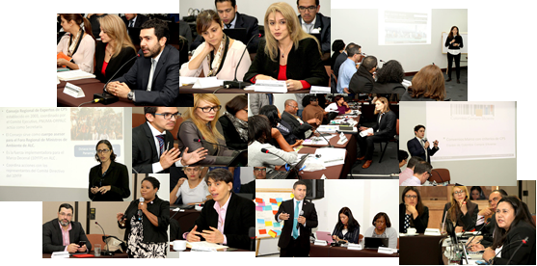

For more details on the presentation and action plans, visit: http://ricg.org/taller-sobre-compras-publicas-sostenibles/contenido/486/es/

4. Methodology and specific results
4.1 Plans of action
Previous to the workshop, the invited participants received a document with two tables to be completed. The document consisted in an exercise of tentative action plan for the implementation of SPP in their country, which served as a base for the discussions of the workshop.
The objective of this exercise was to demonstrate procuring agents that the process of implementing SPP requires preparation, such that there is a need to identify common aspects to those countries who have implemented a similar initiative in order to receive external assistance.
Once these documents were delivered and the IISD revised them, they were exposed in the workshop for commentaries.
Video of the lecture on plans of action and discussions …
4.1.1 Results
The objective of the exhibiting the plans of action was to create dialogue between the participants. Such dialogue was later formalized by an exercise set of questions in order to reach common points and differences within the experiences of the countries. The set of questions facilitated the following conclusions:
- The action plans are different from one another. Some countries appear to be in the early stages of implementing of SPP, meanwhile, others like Colombia, Chile, Costa Rica and Peru are already using modern tools at an international level. Other countries are also working specifically with the Eco-labeling programs o UNEP.
- The advances in SPP are greater in social sustainability and inclusion of SMEs that in environmental sustainability.
- Some of the common tools identified is training, framework agreement, familiarization, dialogue with the market and sustainability sustainable criteria for products.
- Some countries already rely on legislation and policies somewhat specific to SPP such as Peru, Costa Rica, Chile, México, Argentina, Dominican Republic and Paraguay.
- Certain initiatives from countries such as the new SPP policy from Costa Rica, data sheets and framework agreements from Colombia, as well as the women’s program for inclusion of SMEs in Dominican Republic and among others.
- Joint purchasing and framework agreements were strategies named as low-cost for SPP.
- The products prioritized for SPP have coincided with cleaning products, furniture and office supplies and paper.
- Knowledge in SPP from human resources is more of a problem of quality and how many people it is required to implement.

4.2 Discussion rounds: Challenges in the implementation of SPP.
This discussion round was carried out with the objective of constructing a list of the greatest challenges in the implementation of SPP in the region. The exercise was developed with the use of post-its, where participants, through three rounds, were able to relevant state issues of their countries. Later, the ISSD along with the audience, compiled the post-its into common categories which later yielded into a list of common issues.
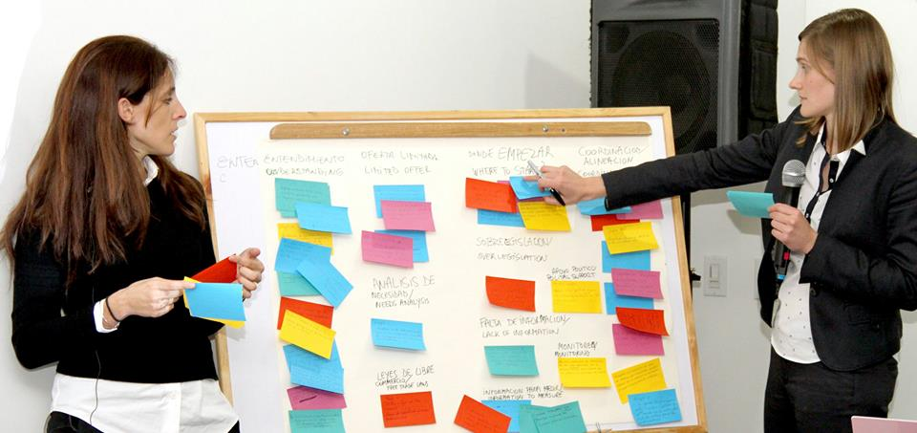

Video…
4.2.1 Results
The aforementioned exercise allowed participants to identify which areas are of priority in SPP at a regional level. Each topic enjoyed a lengthy discussion by the participants in order to reach a consensus on the most important and common topics. Among those identified as challenges in the implementation of SPP were:
- Lack of knowledge in the topic of SPP on behalf of all actors.
- Coordination between government agencies.
- Limited offers.
- How to begin the implementation
- What types of legislation prevents the implementation
- Lack of measuring – Indicators
- Lack of information
- Lack of analysis of the needs
- Need to communicate benefits
- Lack of political support
- Need to verify sustainability criteria
- Conflict FTA laws
- Lack of quantity and quality of Human resources

4.3 Discussion Rounds: Tools for overcoming the challenges in the implementation of SPP.
This discussion round was carried out with the objective of overcoming those obstacles when implementing SPP in the region. Three new rounds of post-its were completed where participants established, to their knowledge, the best tools for overcoming obstacles in the implementation of SPP. Later, the ISSD, along with the participation of the audience, grouped the post-its into common categories reaching a list of common tools.
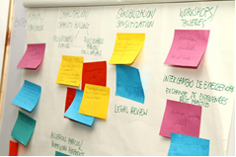

Video…
4.3.1 Results
This exercise reached a list of tools necessary for overcoming implementation obstacles. Each tool had a lengthy discussion until reaching a list of common tools. The list included.
- Training of civil servants
- Handbook for the implementation of SPP
- Training of suppliers
- Sensibilization of procurers
- Exchange of experiences
- Workshops
- Technical assistance
- Development of quality standards
- Creation of framework agreements
- Development of a sustainability criteria for products
- Mesuaring the impact of political support
- Dialogue with the market.
- System of e-procurement
- Pilot tenders
- Incentives for procurer and suppliers
- Joint purchases

4.4 Presentation of ideas to demonstrate the power of SPP as a motor for sustainable development.
This section of the workshop was developed to inspire participants to become more energetic in their SPP tasks. With four presentations regarding how to drive SPP, participants were able to get information on experiences and concrete cases in which tools were successfully applied in practices. The presentations shown in the workshop are accordingly:
- Pilot Tender, Dominican Republic with the assistance of the IISD. This pilot tender was carried out to demonstrate an already successful program in the topic of women inclusion and SMEs in public procurement. This program involves environmental criteria that does not exclude the participation of SMEs and progressively accomplishes a more environmentally sustainable production. Video…
- New National Policy for the Implementation Presented by the Chief of Procurement of Costa Rica. Video…
- Framework Agreements used in Colombia as a motor for accomplishing greater value for money. This initiative was carried out by Colombia Compra Eficiente along with the Ministry of the Environment. Video…
- IISD tool to measure gains from SPP This tool was applied in China, which calculates economic, social and environmental impacts at the time of hiring or buying sustainable goods or services. Video…
4.5 Role Play: How to coordinate with diverse interests in SPP.
The changing of roles exercise concluded the activities of the workshop. The activity consisted of assembling an action plan for the procurement agency of a hypothetical country, where ministries had the opportunity of influencing the chief of procurement to support their policies through SPP.
The participants were divided into groups, where each represented different ministries that are usually involved in the discussions and activities of SPP: Ministry of the Environment, Ministry of Social development and Ministry of finance. The ISSD represented the chief of procurement.
4.5.1 Results
Each group is representative of the ministry, which at the first round exposed its policies of its ministry in the plan of action for the national agency of procurement. Throughout the second round, the group had to propose actions that rebuttal the previous round. This obliged participants to negotiate with other ministries to reach a policy in consensus with others.
The exercise demonstrated that SPP is a key for driving policy and government reform.
Considering the decision making process from the perspective of another interested governmental agency in SPP, the exercise allowed to demonstrate participants that the implementation of SPP consists in the following:
- Various interests in public policy that must be sensibly accorded and coordinated.
- An SPP program must be participative along with other government agencies.
- Those who are interested in SPP, but topics might not necessarily be completely aligned with the job; SPP can be combined in order to deliver different results. For example support to SMEs can produce environmentally sustainable characteristics or buying sustainable products can be linked to products produced by women.

The exercise was developed within the topic of professionalization of the procuring agent. The IISD concluded that even though SPP is led by specialists of procurement, these should later evolve into a specialized procurer in the topic of SPP.
5. Conclusions
The workshop demonstrated a clear advance in the region, not only for the quantity of initiatives but in their process of advocating for SPP. Concepts such as “Value for Money” or the “life cycle of products” begin to familiarize in the vocabulary of the participants and maximum authorities. The director of Colombia Compra Eficiente, María Margarita “Paca” Zuleta stated at the end of the workshop that the authorities of procurement must have the duty of contracting and considering value for money in their decision.
The participants demonstrated an understating of overcoming such challenges such as the perception that sustainable goods are more expensive and that legislation does not allow them to carry out SPP.
There are some initiatives in the spectrum that are emerging while others are already receiving plenty of support in the region as clear tools to become a motor for sustainable development. The role of the IDRC project through the OAS and ISSD has become essential for familiarizing SPP knowledge in these countries.
The workshop also allowed countries to identify the latest in SPP, common challenges and available tools for implementing. A number of economic, social and environmental aspects were considered at the moment of procurement, including the challenges on how to implement and world sophisticated strategies.
The challenge for the future in the region would not only be to buy sustainable goods and services but to hire more vulnerable groups or SMEs, as well as apply more sophisticated and adequate techniques to carry out SPP in a more efficient manner; this however, requires profound changes in systems and procedures.
In conclusion, once the challenges are identified in the implementation of SPP and better tools to develop them, the INGP countries can easily work over a plan of action to identify the working areas, necessary sources of financing and technical support.


